Augmenting Crutches with Wireless Sensors for Lower Limb Rehabilitation

Someone

[example@example.org](mailto:example@example.org)

Personal Tutor: Professor Someone

Abstract: Forearm crutches are frequently used in the rehabilitation of an injury to the lower limb. The recovery rate is improved if the patient correctly applies a fraction of their body weight through the axis of the crutch, referred to as partial weight bearing (PWB). Incorrect PWB has been shown to result in an extended recovery period or even cause further damage to the limb. This paper describes the research and development of an instrumented forearm crutch developed to wirelessly and autonomously monitor PWB over the full period of a patient’s recovery. A pair of crutches are augmented with off-the-shelf wireless sensor nodes and electronic components to provide indicative measurements of applied weight, crutch tilt, and hand grip position. Biofeedback is provided when too much or little weight is put through the crutch. Initial results highlight the ability to support physiotherapists and patients in monitoring patient usage.

1. **Introduction**

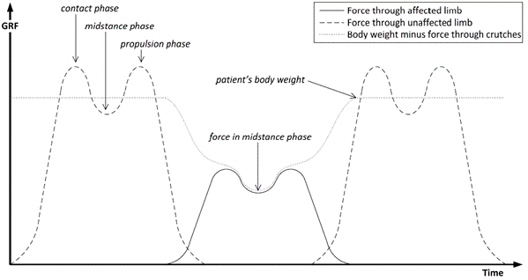

Figure 1: The theoretical forces through the affected limb, healthy limb, and crutches during PWB gait.

Forearm crutches are used routinely following many operations to the lower limb in order to reduce weight-bearing through the affected limb and optimize the healing conditions for bone and soft tissues. Excessive loading of the lower limb following certain types of surgery can disrupt the operated tissues and put the healing bones at risk of mal-union, while mobilisation soon after surgery increases the bone turnover metabolism and stimulates bone growth. [1] It has also been recognized that prolonged unloading of the articular cartilage causes the cartilage to become less stiff and less able to tolerate high loads. [2] Therefore, a programme of partial weight bearing (PWB) usually begins immediately after certain types of surgery and continues until full weight bearing is achieved when there is sufficient healing in the limb.

1. **Software Architecture**

The software system consists of the embedded software on the master and slave crutches, the embedded software on the microcontroller, and the LABView graphical user interface.

**2.1 Embedded Processing**

Having sampled the data from its own sensors and received data from the slave crutch’s sensors, the master crutch estimates the weight through the affected limb in order to provide biofeedback. To understand the reasoning behind this algorithm, consider a typical PWB gait cycle, as shown in figure 1.

Equation (1) is used to calculate the percentage of the patient’s body weight that is translated through their limbs, where and are sets of the sampled magnitudes of the forces through the axes of crutches 1 and 2 during the period of one gait cycle, M is the mass of the patient (kg) and g is the acceleration due to gravity (ms-2).

$W_{actual}^{\%}=1-\frac{max⁡(\left|F_{c1}\left[n\right]\right|+\left|F_{C2}\left[n\right]\right|)}{M∙g}$ (1)

The maximisation is performed over the sum of the forces with respect to n, a discrete time index.

**References**

1. Vasarhelyi, Attila, et al. "Partial weight bearing after surgery for fractures of the lower extremity–is it achievable?." Gait & posture 23.1, 2006, pp. 99-105.
2. Walker, J. M. "Pathomechanics and classification of cartilage lesions, facilitation of repair." The Journal of orthopaedic and sports physical therapy 28.4, 1998, pp. 216.